Python Lab Assignment-3

Name: Saketh Garuda

ID: 16

## Objective:

The main objective for this lab assignment is to know the working of different classification models such Logistic Regression, Linear Discriminant Analysis, Support Vector Machine, KNN and natural language processing in python using NLTK. By using the above methods we met the following objectives,

* Compare contrast logistic regression and linear discriminant analysis
* Calculating best accuracy for the given dataset using the above models
* Applying SVC to different kernels such as Linear and RBF for predicting accuracy
* How KNN algorithm affecting the accuracy of the model

## Features:

The code snippets are executed and debugged for purpose of software environment. The code snippets are written in such way that they won’t affect the performance of the system when they are executed in multiple environments.

## Configuration:

* PyCharm IDE
* Python 3.6.4
* NLTK

## Screenshots:

1) Choosing a dataset and making a prediction model using Linear Discriminant Analysis

## Output:

* Accuracy of the model using Linear Discriminant Analysis model

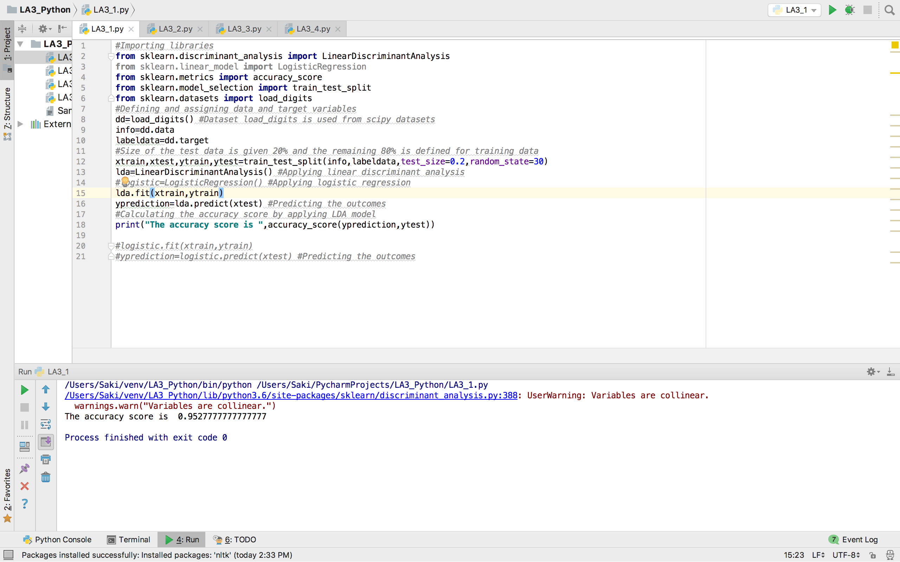

* Accuracy of the model using Logistic Regression model

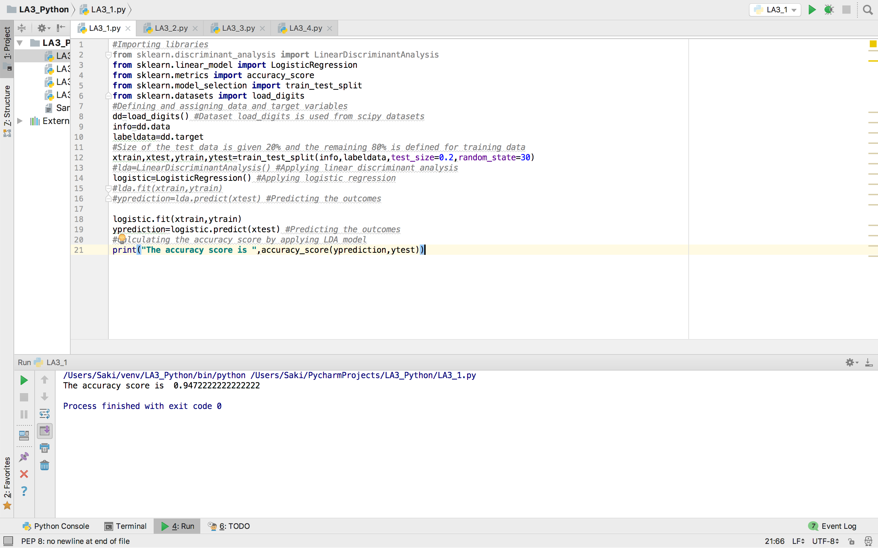

2) Implementing Support Vector Machine classification model on the given dataset using Linear and RBF kernels.

## Output:

* Accuracy with linear kernel and accuracy with RBF kernel

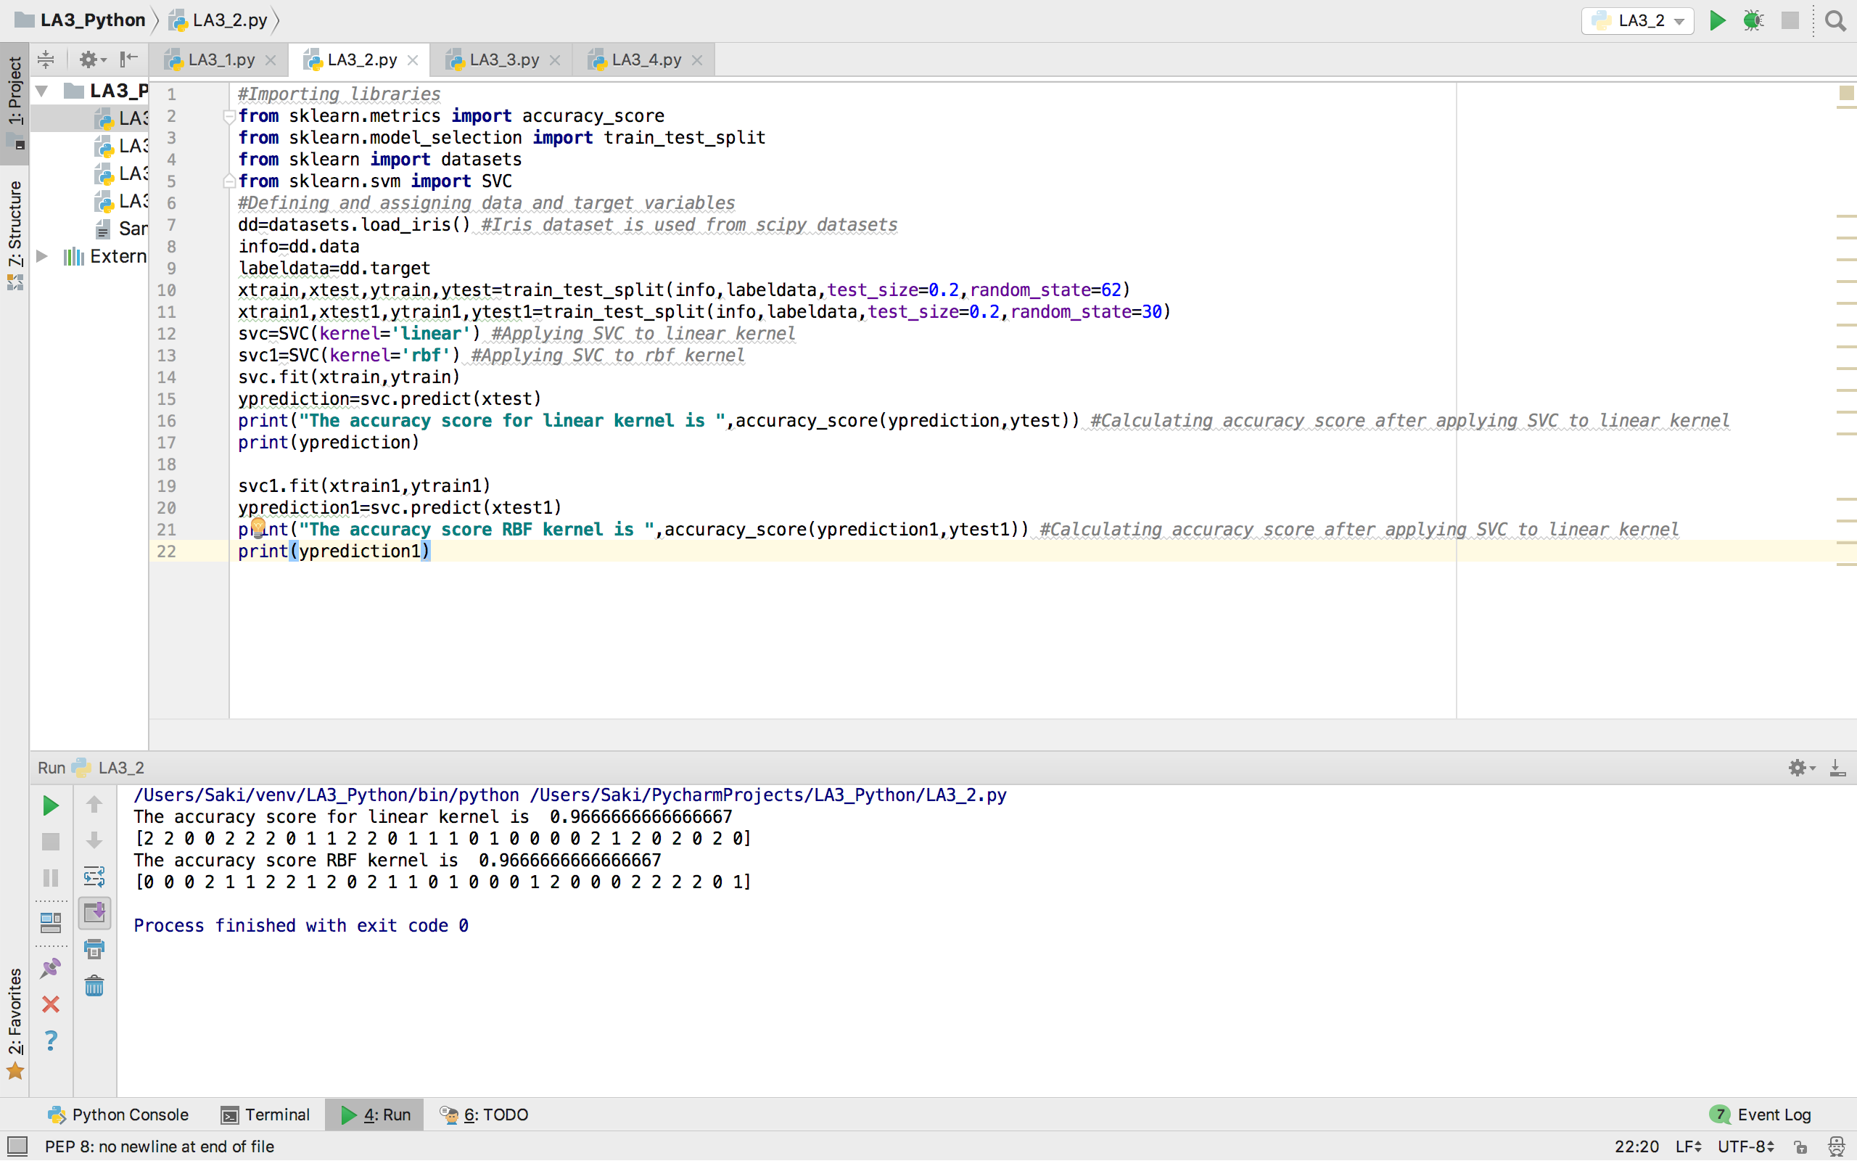

3) Applying lemmatization on a text file and find the word frequency of bi-grams. Also return the top five bigrams from the frequency of bigrams and return the concatenated sentence with the list of top five bigrams.

## Output:

* The output file contains the lemmatized words and list of top five bigrams from the word frequency bigrams. The program also produces the concatenated sentence with the top five bigrams in the text content.

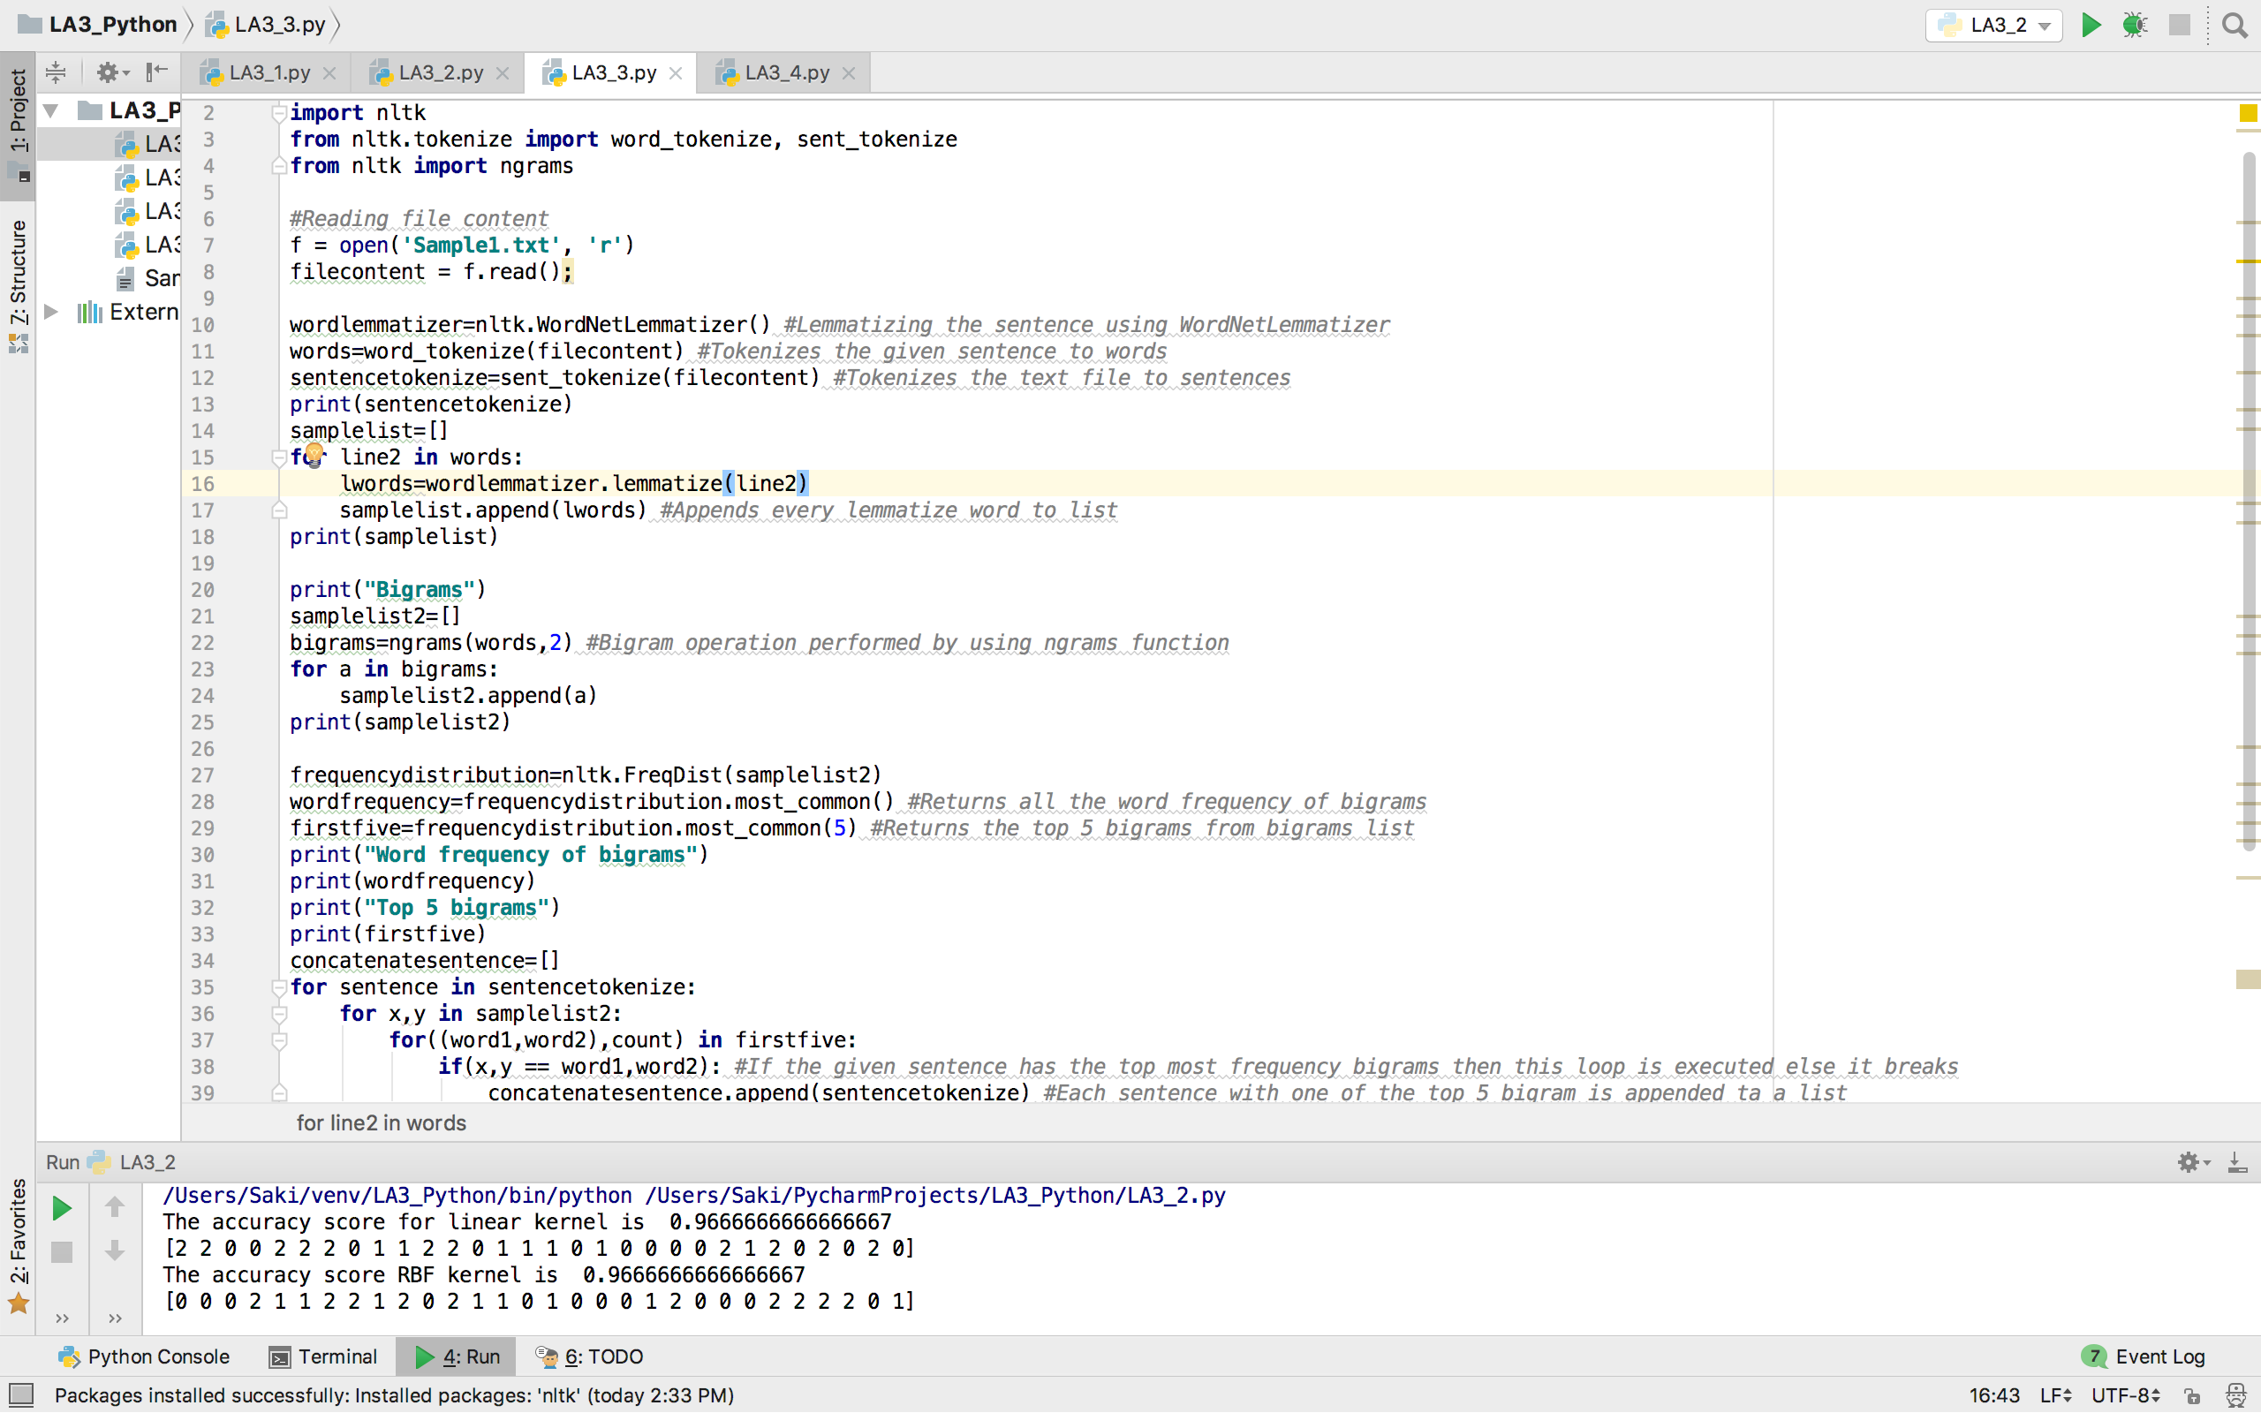

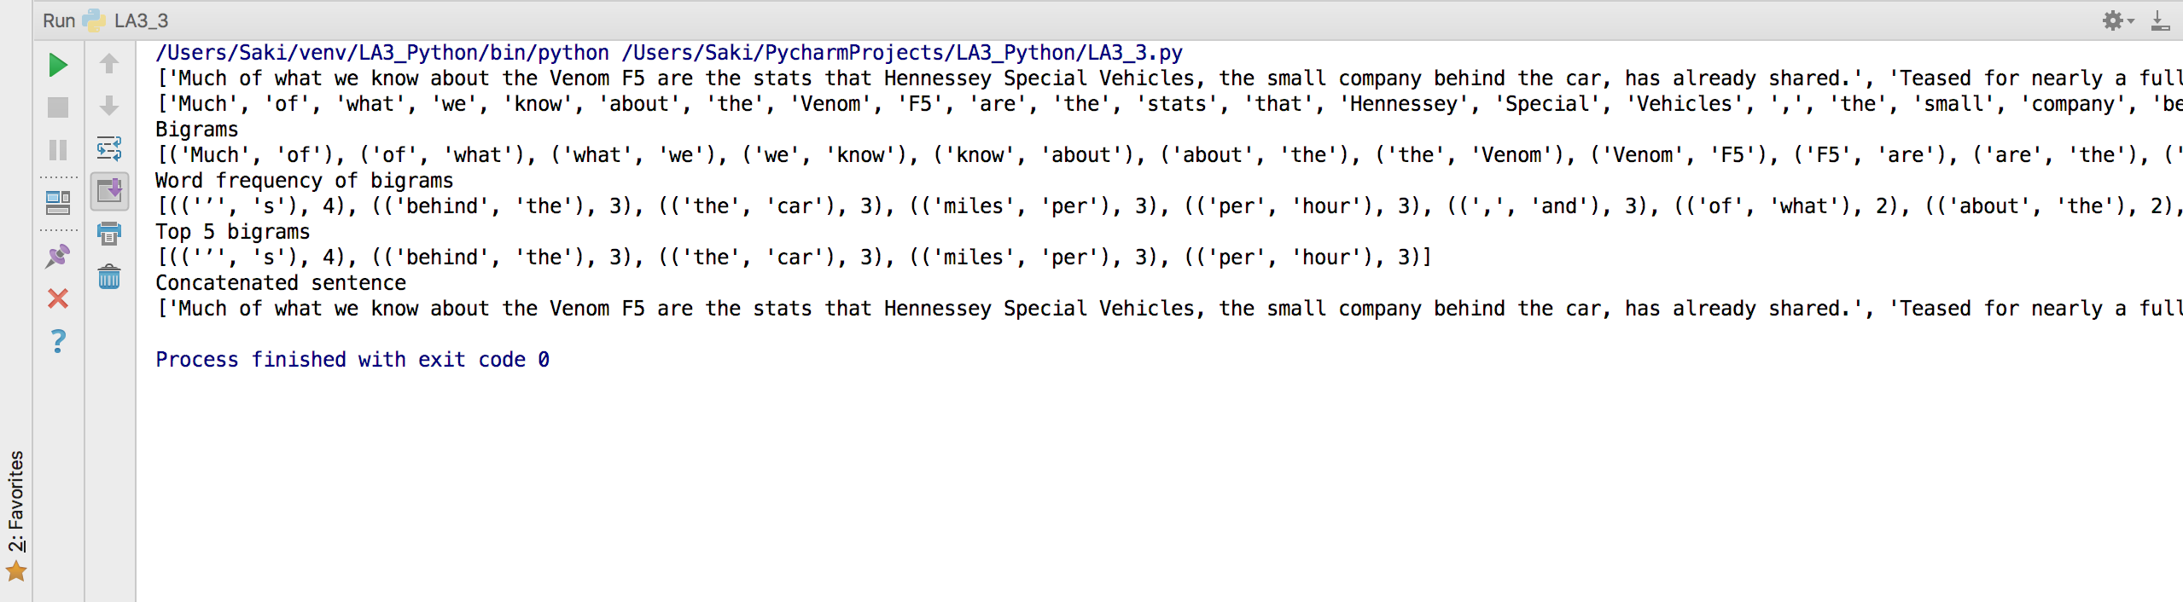

4) Report your views on the k nearest neighbor algorithm and how it affects the accuracy if value of k changes.

## Output:

* Accuracy calculated using knn model with neighbors=1

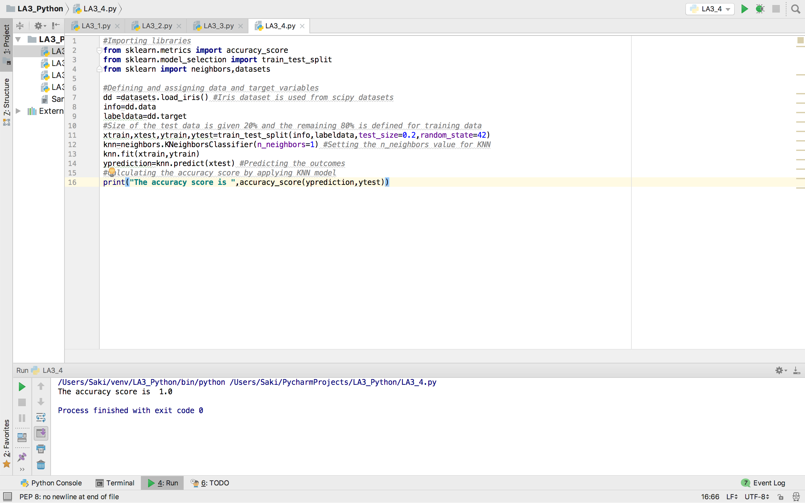

* Accuracy calculated using knn model with neighbors=50

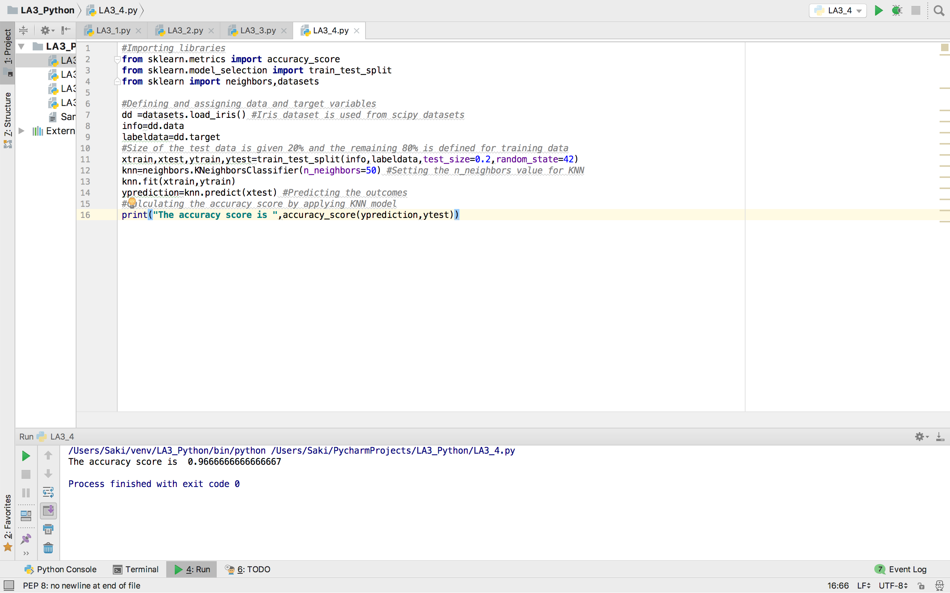

## Code Snippets:

## Solution for Problem 1:

Linear discriminant analysis LDA is applicable where the condition is mutually exclusive such that a dependent variable has two or more groups. Whereas in logistic regression the model is based on the combination of predictors and it provide only conditional distribution. Both LDA and Logistic regression models are based on linear-odd assumption but they estimate coefficients in different techniques.

## Code Snippet 1:

*#Importing libraries***from** sklearn.discriminant_analysis **import** LinearDiscriminantAnalysis  
**from** sklearn.linear_model **import** LogisticRegression  
**from** sklearn.metrics **import** accuracy_score  
**from** sklearn.model_selection **import** train_test_split  
**from** sklearn.datasets **import** load_digits  
*#Defining and assigning data and target variables*dd=load_digits() *#Dataset load_digits is used from scipy datasets*info=dd.data  
labeldata=dd.target  
*#Size of the test data is given 20% and the remaining 80% is defined for training data*xtrain,xtest,ytrain,ytest=train_test_split(info,labeldata,test_size=0.2,random_state=30)  
*#lda=LinearDiscriminantAnalysis() #Applying linear discriminant analysis*logistic=LogisticRegression() *#Applying logistic regression  
#lda.fit(xtrain,ytrain)  
#yprediction=lda.predict(xtest) #Predicting the outcomes*logistic.fit(xtrain,ytrain)  
yprediction=logistic.predict(xtest) *#Predicting the outcomes  
#Calculating the accuracy score by applying LDA model*print(**"The accuracy score is "**,accuracy_score(yprediction,ytest))

## Code Snippet 2:

*#Importing libraries***from** sklearn.metrics **import** accuracy_score  
**from** sklearn.model_selection **import** train_test_split  
**from** sklearn **import** datasets  
**from** sklearn.svm **import** SVC  
*#Defining and assigning data and target variables*dd=datasets.load_iris() *#Iris dataset is used from scipy datasets*info=dd.data  
labeldata=dd.target  
xtrain,xtest,ytrain,ytest=train_test_split(info,labeldata,test_size=0.2,random_state=62)  
xtrain1,xtest1,ytrain1,ytest1=train_test_split(info,labeldata,test_size=0.2,random_state=30)  
svc=SVC(kernel=**'linear'**) *#Applying SVC to linear kernel*svc1=SVC(kernel=**'rbf'**) *#Applying SVC to rbf kernel*svc.fit(xtrain,ytrain)  
yprediction=svc.predict(xtest)  
print(**"The accuracy score for linear kernel is "**,accuracy_score(yprediction,ytest)) *#Calculating accuracy score after applying SVC to linear kernel*print(yprediction)  
  
svc1.fit(xtrain1,ytrain1)  
yprediction1=svc.predict(xtest1)  
print(**"The accuracy score RBF kernel is "**,accuracy_score(yprediction1,ytest1)) *#Calculating accuracy score after applying SVC to linear kernel*print(yprediction1)

## Code Snippet 3:

*#Importing libraries***import** nltk  
**from** nltk.tokenize **import** word_tokenize, sent_tokenize  
**from** nltk **import** ngrams  
  
*#Reading file content*f = open(**'Sample1.txt'**, **'r'**)  
filecontent = f.read();  
  
wordlemmatizer=nltk.WordNetLemmatizer() *#Lemmatizing the sentence using WordNetLemmatizer*words=word_tokenize(filecontent) *#Tokenizes the given sentence to words*sentencetokenize=sent_tokenize(filecontent) *#Tokenizes the text file to sentences*print(sentencetokenize)  
samplelist=[]  
**for** line2 **in** words:  
 lwords=wordlemmatizer.lemmatize(line2)  
 samplelist.append(lwords) *#Appends every lemmatize word to list*print(samplelist)  
  
print(**"Bigrams"**)  
samplelist2=[]  
bigrams=ngrams(words,2) *#Bigram operation performed by using ngrams function***for** a **in** bigrams:  
 samplelist2.append(a)  
print(samplelist2)  
  
frequencydistribution=nltk.FreqDist(samplelist2)  
wordfrequency=frequencydistribution.most_common() *#Returns all the word frequency of bigrams*firstfive=frequencydistribution.most_common(5) *#Returns the top 5 bigrams from bigrams list*print(**"Word frequency of bigrams"**)  
print(wordfrequency)  
print(**"Top 5 bigrams"**)  
print(firstfive)  
concatenatesentence=[]  
**for** sentence **in** sentencetokenize:  
 **for** x,y **in** samplelist2:  
 **for**((word1,word2),count) **in** firstfive:  
 **if**(x,y == word1,word2): *#If the given sentence has the top most frequency bigrams then this loop is executed else it breaks* concatenatesentence.append(sentencetokenize) *#Each sentence with one of the top 5 bigram is appended ta a list*print(**"Concatenated sentence"**) *#The final concatenated sentence*print(max(concatenatesentence))

## Solution for Problem 4:

The accuracy is affected whenever the K value is increased or decreased as it affects the test data point that belongs to the same class or different class. When K decreases i.e. K=1, the resolution is too fine which makes the model over fit and results in less accuracy. Whereas K increases i.e. K=50, then the model is said to be under fit and provide correct classification which results in best accuracy.

## Code Snippet 4:

*#Importing libraries***from** sklearn.metrics **import** accuracy_score  
**from** sklearn.model_selection **import** train_test_split  
**from** sklearn **import** neighbors,datasets  
  
*#Defining and assigning data and target variables*dd =datasets.load_iris() *#Iris dataset is used from scipy datasets*info=dd.data  
labeldata=dd.target  
*#Size of the test data is given 20% and the remaining 80% is defined for training data*xtrain,xtest,ytrain,ytest=train_test_split(info,labeldata,test_size=0.2,random_state=42)  
knn=neighbors.KNeighborsClassifier(n_neighbors=1) *#Setting the n_neighbors value for KNN*knn.fit(xtrain,ytrain)  
yprediction=knn.predict(xtest) *#Predicting the outcomes  
#Calculating the accuracy score by applying KNN model*print(**"The accuracy score is "**,accuracy_score(yprediction,ytest))

## Deployment:

The code snippets are written using Python IDE and executed with the help of python 3.6.4 interpreter. Outputs are shown in the Python IDE console.

## Limitations:

The given code snippets doesn’t have any limitations as they have met all rules and conditions.

## References:

* <http://scikit-learn.org/stable/modules/generated/sklearn.linear_model.LogisticRegression.html>
* <http://scikit-learn.org/stable/modules/svm.html>
* <http://scikit-learn.org/stable/modules/neighbors.html>
* <http://www.nltk.org/book/ch01.html>
* <http://scikit-learn.org/0.16/modules/generated/sklearn.lda.LDA.html>